Unit one

Myths and Legends
Y3

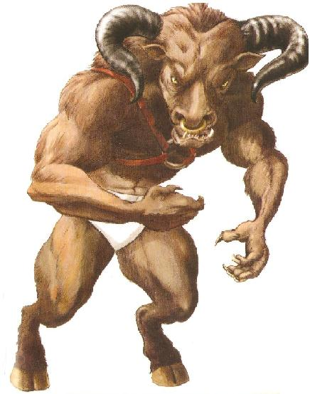

Developing the writing skills of
advanced EAL learners

Belmont Primary School, Harrow

Paula O’Hallaron & Lucy Banyard (Y3 teachers)
Alice Washbourne (Associate Consultant, The EAL Academy)
Myths and Legends Resources Overview

Literacy objective: to write a mythical story

Success criteria:
- powerful vocabulary
- descriptive setting and creature
- exciting description of the struggle
- past tense verbs
- time connectives

RESOURCES | PUPIL ACTIVITY | TEACHER NOTES
1. Character picture and name cards | Place cards face up on the group’s table.  Discuss in groups:  What do you already know about these characters? | Video of Daedalus and Icarus story:  http://myths.e2bn.org/mythsandlegends/view_myth.php?id=1598  Take feedback from pupils before showing the video.  Then ask:  What type of story is it?  What words and phrases will you hear?
2. Vocabulary cards | In a group sort cards into words/ phrases you understand and words/ phrases you don’t understand.  Listen to the story. Place card next to the character that it refers to.  Retell story in pairs orally using the character and word cards to help. Try and include at least 5 powerful words/ phrases | Take feedback on words/ phrases pupils don’t know. Ask the class if anyone can help. If no-one knows explain.
3. Storyboard | Draw pictures of key events and write captions/ sentences underneath
4. Analysis grid for Daedulus and Icarus | Make notes in boxes to understand the key elements of the story structure.
5. Analysis grid for other stories | Read other stories in pairs or small groups, discuss and make notes in the grid | Teachers need to collect a wide range of myths and legends stories at different levels of reading challenge suitable for the pupils in their class. Try and represent stories from countries around the world that reflect pupils’ home backgrounds.
6. Adjectives and adverbs cloze activity  (2 levels) | Pupils work in pairs and discuss ideas of what words could go in the gaps. Agree best choices and write in. | Take feedback from pupils and comment on suggestions.  Which ones are most effective and why?
7. Picture sequence and word cards | Pupils work collaboratively to match words and pictures and sequence them in a logical order. Then watch video and check the actual sequence. | The girl and the Fox video story:  http://www.literacyshed.com/the-myths-and-legends-shed.html
8. Story mountain and opening | In pairs place events cards onto the story mountain sheet. | Take feedback.  Show PPT slide with answers for pupils to check.  Show the model story opening (describing the setting) and talk through your decisions as a writer. Tell them you are stuck. Ask pupils to help you continue to describe the setting.
9. Teacher story writing | (This is not a pupil resource) | It is important that teachers write the text they expect the pupils to write for themselves first. This helps to identify the potential difficulties for pupils and clarifies the natural elements of the text type. It also provides a useful resource that can be used to model different aspects of the text. Eg How to write a descriptive setting.
10. Verbs to describe fast movement word bank | In pairs pupils mime one of the verbs to their partner, who guesses which word on the list it is.  Pupils have the word bank available and use it in their writing. | The purpose of this resource is to extend pupils’ vocabulary and use of past tense in narrative writing.

